MONDAY | TUESDAY | WEDNESDAY | THURSDAY | FRIDAY
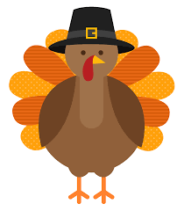 |  |  |  | 11/1  B-Bagel with Jelly, Milk  L-Chicken Sandwich, Baked Beans, Apples, Milk  S-Graham Crackers, Milk
11/4  B-Cereal, Pears, Milk  L-Turkey and Cheese Sliders, Cucumber and Tomato Salad, Apple Juice  S-Sun Chips, Milk | 11/5  B-Oatmeal, Apples, Milk  L-Chicken Nachos, Pineapple, Milk  S-Chex Mix, Milk | 11/6  B-Waffles, Strawberries, Milk  L-Beef burger, Baked Beans, Mandarin oranges, Milk  S-Teddy grahams, Milk | 11/7  B-Cereal, Bananas, Milk  L-Popcorn chicken, Mashed potatoes, Corn, Apple juice  S-Pretzels, Milk | 11/8  B-Pancakes, Blueberries, Milk  L-Pizza, Broccoli, Apple juice  S-Cookies, Milk
11/11  Center Closed  Veterans Day | 11/12  B-Raisin bran, Peaches, Milk  L-Turkey and cheese sandwich, Green beans, Pineapple, Milk  S-Sun chips, Milk | 11/13  B- Bagel with Jelly, Milk  L-Spaghetti with turkey meatballs, Apple juice  S-Chex mix, Milk | 11/14  B-Oatmeal, Strawberries, Milk  L-Chicken patty, Tator tots, Apple juice  S-Doritos, Milk | 11/15  B-Cinnamon toast crunch, Pears, Milk  L-BBQ chicken pizza, Salad, Milk  S-Cranberry brownies, Milk
11/18  B-Cream of wheat, Blueberries, Milk  L-Grilled cheese, Tomato Soup, Apple juice  S-Goldfish, Milk | 11/19  B-Waffles, Turkey sausage, Orange juice  L-Taco bowls, Peaches, Milk  S-Teddy grahams, Milk | 11/20  B-Cheerios, Bananas, Milk  L-Chicken alfredo, Broccoli, Apple juice  S-Vanilla wafers, Milk | 11/21  B-Blueberry muffins, Milk  L-Mozzarella sticks, Marinara, Mixed vegetables, Apple juice  S-Cheetos, Milk | 11/22  B-Breakfast bar, Apples, Milk  L-Pizza, Green beans, Apple juice  S-Sun chips, Milk
11/25  B- Rice crispies, Mandarin oranges, Milk  L-Baked chicken, Mac and cheese, Candied yams, Green beans, Milk  S-Pound Cake with Vanilla ice cream | 11/26  B- Chocolate Chip muffins, Pears, Milk  L- Beef tacos, Yellow rice, Peaches, Milk  S-Cookies, Milk | 11/27  B-French toast, Strawberries, Milk  L-Turkey and cheese wrap, Salad, Apple juice  S-Pretzels, Milk | 11/28  Center Closed  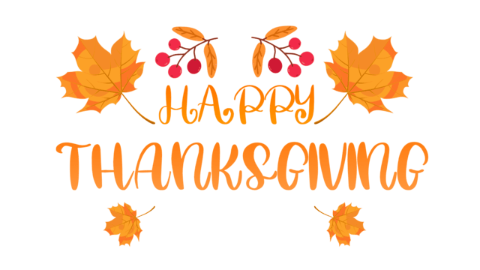 | 11/29  Center Closed  